**Web Design and Development**

**For 13-0**

**By : VL 12-0**

“Bluejack CV” is an CV management website created for Bina Nusantara Teaching Assistant. This website provide interactive CV page for all their member and allow other people to leave a message for the member if they are interested in their CV.

**Sitemap of this site :**

* **For unlogged user (Guest)**
* Home Page
* Generation List
* Member List
* About (Company Profile)
* **For logged user (User)**
  + Home Page
  + Generation List
  + Member List
  + My Generation
  + My Profile
  + Message
  + About (Company Profile)
* **For logged user (Admin)**
  + Home Page
  + Generation List
  + Member List
  + My Generation
  + My Profile
  + Message
  + Admin Panel
  + About (Company Profile)

1. **Home Page**

This page contains **login form**, simple explanation about the website, **slider image for last 5 generation**, and **5 random Bluejack Member Profile**. Also make “Forgot Password” feature, which will **sent** the **new password** to the member Email.

1. **Generation List**

This page contains all list of available Bluejack generation which exists in website database with their **profile picture** and **motto**. This page has **paging** feature.

1. **Generation Page**

This page contains **member list of the generation**, **profile picture**, **motto**, and **picture album**. This page has **paging** and **searching** feature for their member.

1. **My Generation**

This page contains all information about the member generation, and generation member list. Member also can edit some information about their generation.

Generation information which can be edited are :

1. Motto
2. Profile Picture
3. Picture Album

Only member of generation can edit the information. Also, **random the file name** to avoid picture with the same name. The member can also **remove picture** from their generation album.

1. **My Profile**

This page is used to **view** and **edit** current user profile and portfolio which will be shown as their CV.

User’s profile which can be edited are :

1. Profile Photo
2. Personal Information
   * First Name (must be filled and alphabet)
   * Last Name (must be alphabet)
   * Email (must be filled and in true format)
   * Address (must be filled)
   * City (must be filled)
   * Phone (must be filled and numeric, **hide** from **Guest**)
   * Gender (must be filled)
   * Birth Place / Date (must be filled)
   * Nationality (must be filled)
   * Religion (must be filled)
3. Education
   * Formal Education
     + Start Date (must be filled)
     + End Date (must be filled)
     + Place (must be filled)
     + Degree (must be filled)
     + Major
     + GPA
   * Informal Education
     + Start Date (must be filled)
     + End Date (must be filled)
     + Place (must be filled)
     + Information (must be filled)
4. Certification
   * Year (must be filled)
   * Information (must be filled)
5. Skill
   * Language Skill
     + Language (Speaking, Writing, Reading) (must be filled)
   * Programming Skill
     + Category (must be filled)
     + Information (must be filled)
6. Working Experience
   * Start Date (must be filled)
   * End Date (must be filled)
   * Place (must be filled)
   * Status
   * Job Description
7. Portfolio
   * Image
   * Title
   * Description
8. Other Information

User also can **add**, **change**, or **delete** their Portfolio which consists of **Image**, **Title**, **Description** and **File**. User can **add** more than 1 image to their Portfolio and can be **viewed** if someone see their portfolio.

1. **Profile Page**

This page is used to allow **Guest** view member CV, view member location via **city** in **Google Maps** and **leave a message** if they are interested for hiring the member. All image in the Portfolio can be **enlarged** if clicked. (use **jQuery** **AJAX** and **JSON** to load information from database if one category is selected)

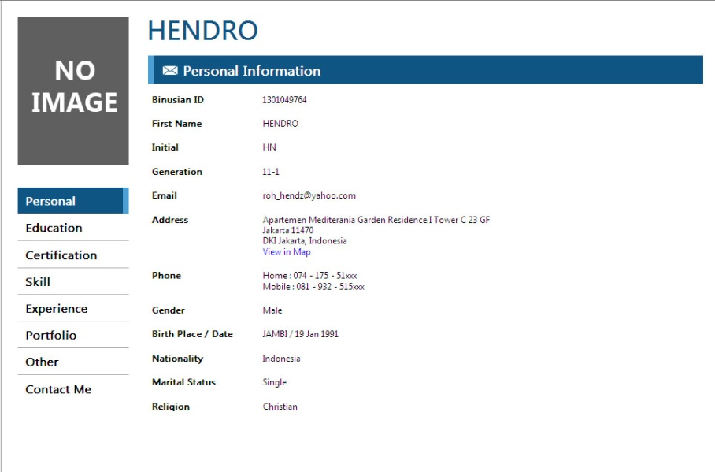

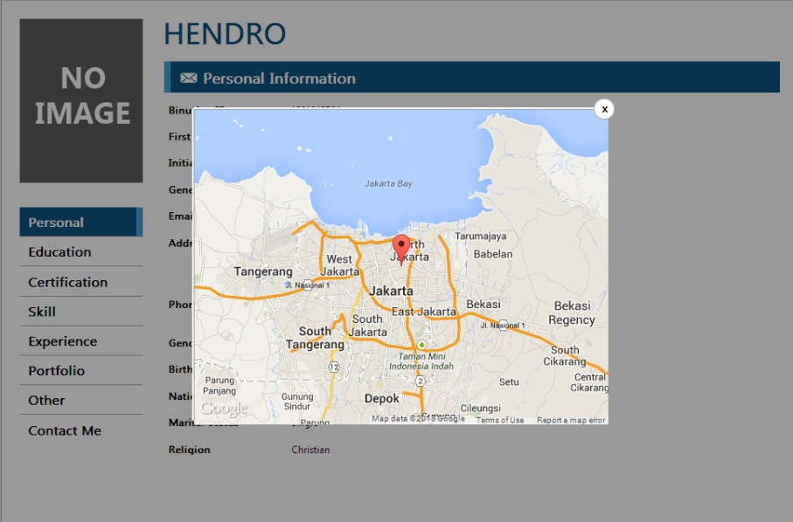

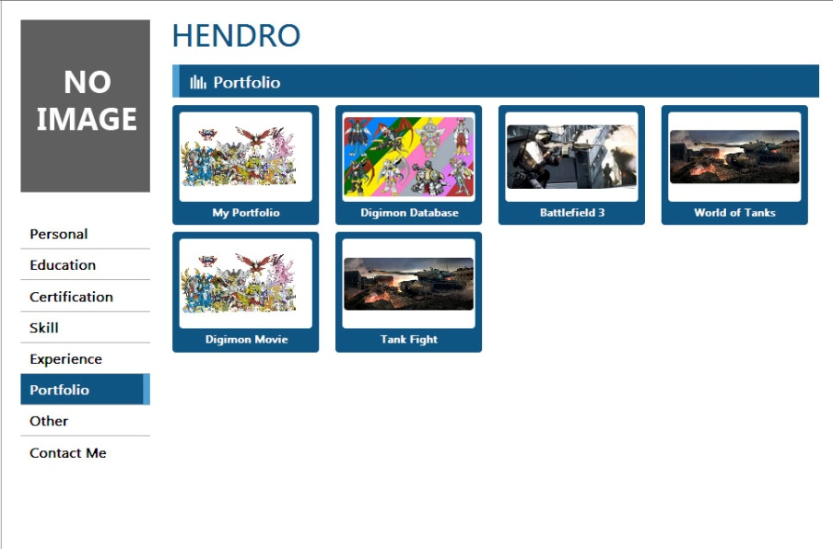

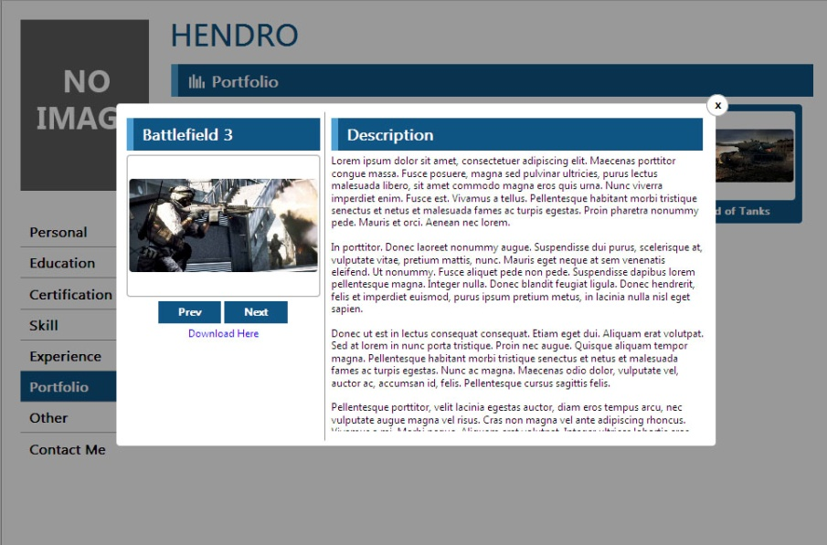

1. **Message**

This page is used by member to **view** and **remove** if there are Guest who **leave a messages** for them, and allow them to **send an Email** to the Guest. Give **auto complete** feature for member to choose which email they want to reply.

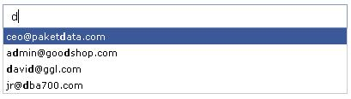

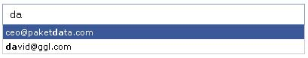

1. **Admin Panel**

This page is used by admin to manage **Generation** and **Member**. Give admin a feature to **parse** Bluejack member data from an **excel file**.

1. **Web Logo**

Design a logo for your website using Adobe Illustrator. Do not use any external image and minimum 1 **Pathfinder** feature!

1. **Mobile Version**

Provide feature for all user to open member CV in **mobile version** if website is accessed from mobile devices.

1. **Other Criteria**

* Interactive Design
* Layout using Div
* Use CSS3 (min 5 different attribute)
* Use HTML5 (min 5 different tag)
* Use jQuery (min 5 different function)
* Make slider with CSS animation (Pure CSS)
* Javascript / jQuery plugin is allowed (except for slider)
* Use drag and drop feature to upload file
* Web Consistency
* Use page title and meta tag
* Use label for tag input
* Use internal documentation for html, php and CSS
* Use Full AJAX and JSON to load CV portofolio content dynamically
* Use placeholder tag for form component
* Site code must validate to **XHTML 1.1**
* Security Detail :
  + Encrypt Password in Database
  + Prevent SQL Injection
* Use htaccess for tidy URL
* Convert Profile to PDF (by HN)
* LESS is allowed
* Use HTML5 for Validation